# Lab-4-2: Azure Operations with Powershell

# Objectives

* Use Azure portal to create virtual machine to host webapp
* Learn how to Connect to Azure account from powershell
* Create virtual machine from powershell



**Part 1: Exercise:**

1. **Follow the link below to create VM to host webapp:**

<https://docs.microsoft.com/en-us/azure/virtual-machines/windows/quick-create-portal>

Q1. Paste screen shot of your RDP connection

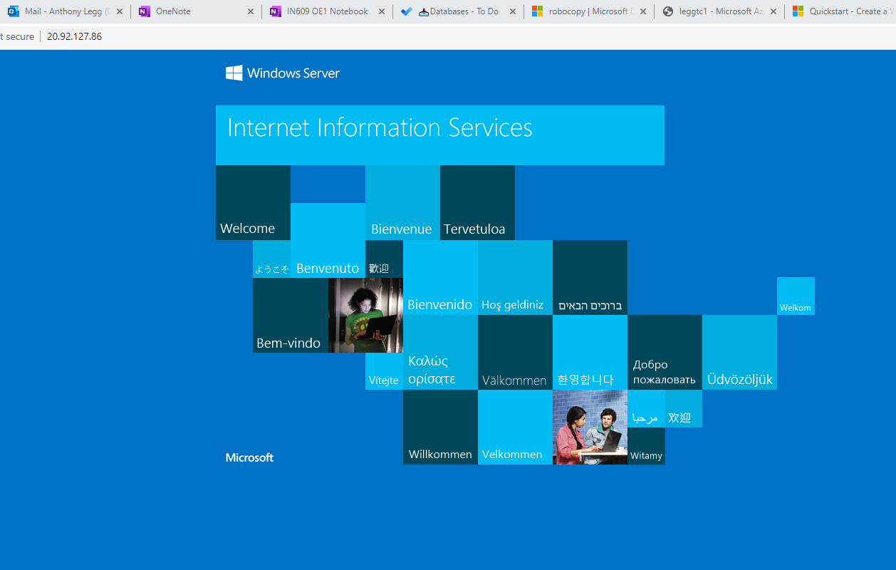

**Part 2: Azure operations with Powershell ISE**

1. Connect your local powershell ISE to your Azure subscription.

[hints: Install-Module -Name Az -AllowClobber -Force

Import-Module -Name Az

Connect-AzAccount -Tenant 450e6824-88ab-4ad2-914d-b0f385da600c -Subscription ee67cd86-3ab6-4382-81f9-9e62f569ffc6

Get-AzSubscription

PS C:\Users\leggtc1> Connect-AzAccount -Tenant 450e6824-88ab-4ad2-914d-b0f385da600c -Subscription ee67cd86-3ab6-4382-81f9-9e62f569ffc6

Account SubscriptionName TenantId Environment

------- ---------------- -------- -----------

LEGGTC1@student.op.ac.nz Azure School of ICT 450e6824-88ab-4ad2-914d-b0f385da600c AzureCloud

PS C:\Users\leggtc1> Get-AzSubscription

Name Id TenantId State

---- -- -------- -----

Azure for Students fbf3e5e5-0b66-4589-87ec-9327c97e0dff 450e6824-88ab-4ad2-914d-b0f385da600c Enabled

Azure School of ICT ee67cd86-3ab6-4382-81f9-9e62f569ffc6 450e6824-88ab-4ad2-914d-b0f385da600c Enabled

**Q2.1. Paste screen shot of your command execution.**

1. Create a new vm on the IN609OE1 resource group with the following details:

New-AZVM

ResourceGroupName = 'IN609OE1'

Name = ‘<yourid>-lab72’

Location = 'australiaeast'

ImageName = 'Win2016Datacenter'

PublicIpAddressName = '<yourid>-publicip'

Credential = $cred

OpenPorts = 3389

52.187.231.131

[Hints: You can create credentials using Get-Credential

Create vms using New-AzVm ]

**Q2.2 Paste screenshot of your RDP connection.**